DATA ANALYTICS CAPSTONE
Comprehensive Analytics Report
Francky Ciceron – DAB July 2025

- Introduction
Pennsylvania’s higher education landscape is diverse, but access, affordability, and outcomes vary widely by county, institution type, program duration, and campus settings. This project investigates geographic distribution, ownership structures, and cost-outcome dynamics to uncover patterns and disparities. To achieve that objective, we tried to answer the following business questions:
  - Where are institutions concentrated or missing across counties?
  - How do ownership types affect affordability and graduation rates?
  - What role do degree-level focus and program duration play in institutional accessibility?

- Data collection/selection and preparation approach

  - Why this data set was chosen:
The dataset contains Institutions' names, addresses, IPEDS ID, campus settings, awards offered, graduation rate, and cohort year, which offer rich potential for analyzing geographical trends, institution count, affordability, outcomes by ownership type, and environmental settings. The goal was to uncover patterns that could inform student decisions and policy strategy. My choice is also driven by my curiosity to gain a deeper understanding of higher education dynamics in the state where I am currently living.
  - Data collection and cleaning process
The dataset was collected from the National Center for Education Statistics website and filtered for the state of Pennsylvania. https://nces.ed.gov/collegenavigator/. It was enriched with county names using a ZIP code lookup table from GitHub’s Free Zipcode Data project. ZIP Code Database - ZIP Code List (Updated for 2025).
Before performing any analysis, the raw dataset was reviewed so that it could be initially cleaned in Excel to ensure accuracy, consistency, and usability.
  - Issue identified
- Missing values across many columns.
- Inconsistent formatting in many of the columns, mainly the Cohort Year and OPE IDs.

  - Cleaning Actions Taken
To start the initial cleaning process of the dataset, multiple actions have been taken into consideration. The following two columns were split to facilitate analysis:
- Address: That column in the raw dataset was split into four new columns (Street, City, State, and Zip Code)
- Type: That original column was split into two new columns (Duration and Type of Ownership)
After that first step, the dataset was verified for consistency and imported into Python for deeper cleaning and analysis.

  - Analytical Process & Methodology
Multiple tools were used during that research:
- As stated above, Excel was utilized for initial data cleaning.
- Python was used for advanced data cleaning, including imputation for missing values, summary statistics, and the creation of calculated fields.
- Tableau was used for data visualization and for the creation of calculated fields.

Key variables added/ calculated field created:
- Ownership Type: Categories include Public, Private Nonprofit, and Private For-Profit.
- Degree Level Focus: Options are Primarily Associate or Mixed/Unknown.
- Institution Count: Determined using COUNTD using IPEDS ID.
- Duration Category: Essential for analyzing program length.
- Merge the cleaned dataset with the County lookup table, using the Zip Code.

After that step, the dataset was verified for consistency and imported into Tableau for visualization, where some additional fields were also created. Among other graphs, we can include:
- Geographic mapping by county
- Comparative analysis of Net Price and Graduation Rate
- Aggregation by ownership type and degree level
- Comparative analysis of outcome by Duration and Environment Settings

- Presentation of Key Findings
This capstone project explores the geographic distribution, affordability, and graduation rates of higher education institutions across Pennsylvania. The analysis identifies the primary drivers of graduation rate performance, revealing critical disparities related to program duration and geographic setting, and establishing the cost context for these outcomes.
  - Geographic and Organizational Context
• Geographic Concentration: Institutions are heavily clustered in the Eastern Region of the state, particularly in counties like Philadelphia (33) and Montgomery (23), setting the stage for regional analysis.
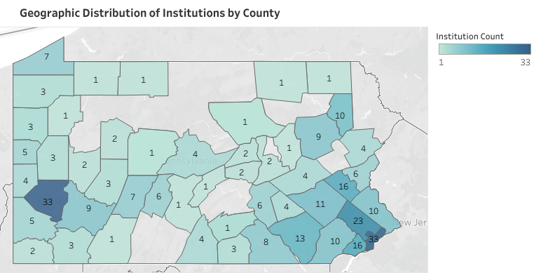

• Market Composition: The sector is dominated by Private Not-for-Profit institutions (the largest group by count), followed by For-Profit and Public institutions.
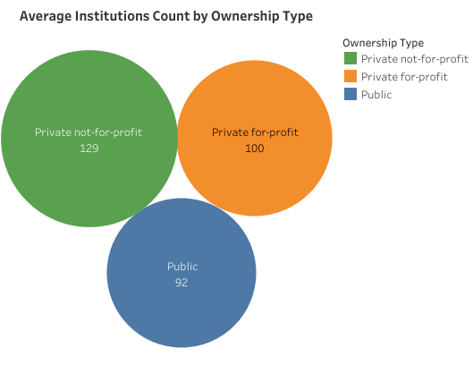
• Cost vs. Ownership: Public institutions are more affordable. While Private Not-for-Profit institutions also carry the highest average net price, establishing a clear link between organizational structure and student cost, Private for-profit institutions, however, show stronger graduation outcomes.

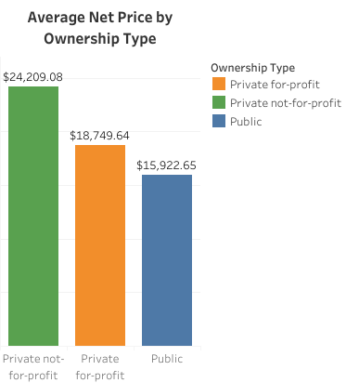 | 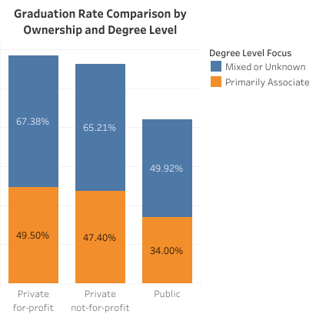

  - Performance Drivers and Core Insights
The analysis of graduation rates by program duration and environmental setting yielded two major findings:
- The Surprising Strength of Short-Term Programs
• Programs under two years in duration consistently achieve the highest average graduation rates across all four campus settings (City, Rural, Suburb, and Town).
• The single highest-performing category is the Rural < 2-year program (72% average graduation rate). This suggests that short, vocational, or technical programs are highly effective mechanisms for completion statewide.
- Critical Vulnerabilities in Four-Year Programs
• The most significant weakness identified is in Rural 4-year programs, which exhibit an alarming average graduation rate of only 40%. This is the lowest-performing category across the entire dataset, signaling a need for immediate intervention and resource allocation in this specific institutional type.
• The most significant weakness identified is in Rural 4-year programs, which exhibit an alarming average graduation rate of only 40%. This is the lowest-performing category across the entire dataset, signaling a need for immediate intervention and resource allocation in this specific institutional type.
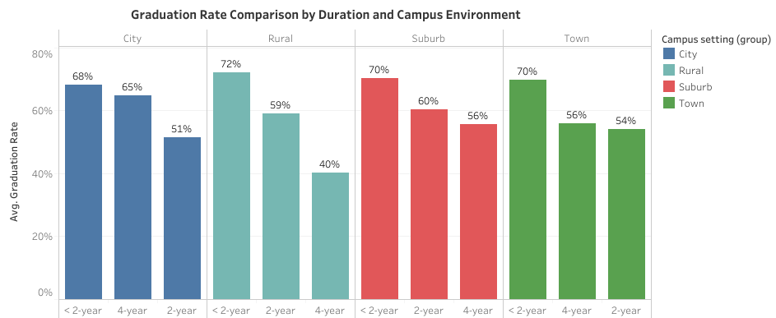

  - Performance by Environment (Campus Setting)
• Suburb institutions show the most reliable and highest median performance. This environment provides the strongest consistency across its institutions.
• City and Town settings show greater volatility, with medians generally lower than Suburb, and performance is heavily reliant on program duration rather than the setting itself.
• The Box Plot successfully isolates individual institution performance, enabling targeted focus on low-performing schools that fall below the expected range for their respective settings.
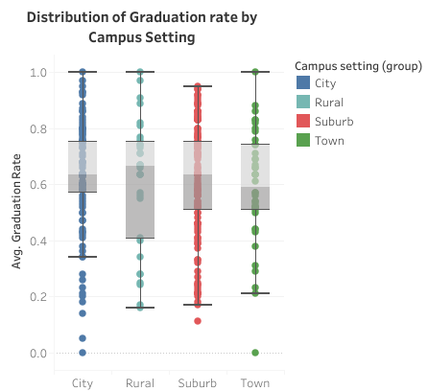

- Recommendations
Based on the above key findings, the following recommendations could guide not only students but also policy and educational planners in Pennsylvania to make better decisions in the future.
1. Expand Access in Underserved Counties
Counties with few or no institutions, especially in Central and Northern Pennsylvania, should be prioritized for expansion of Public or Non-Profit campuses to improve geographic equity.
2. Support Longer Programs in Rural Areas
Graduation rates for 4-year programs in rural settings are significantly lower than their short-term counterparts. Targeted support, funding, or advising initiatives could help improve outcomes.

3. Improve Transparency Around Cost and Outcomes
Students should have access to clear comparisons of Net Price and Graduation Rates by Ownership Type and Program Duration. This could guide better decision-making and reduce debt burdens.
4. Leverage Suburban Campus Models
Suburban institutions show consistent performance. Their operational models could be studied and adapted to improve outcomes in Town and Rural settings.
5. Use Data to Inform Policy and Outreach
- Policymakers and educational planners should use this kind of analysis to align funding, sensitization programs, and institutional support with areas of greatest need and opportunity.
- State policy should prioritize and recognize institutions where the performance of their shortest programs (< 2-year) and longest programs (4-year) is consistently high, encouraging holistic excellence across the institution’s entire offering portfolio.

- Potential Next Step
This dataset could be enriched with County population data for deeper access analysis.

APPENDIX

    - Data Cleaning Plan: DAB-workshops/Data Cleaning Plan - Capstone Francky Ciceron.docx at main · Francky70/DAB-workshops

    - Coding in Python for data cleaning and calculated fields: DAB-workshops/Capstone Project Francky Ciceron.ipynb at main · Francky70/DAB-workshops

    - Visualization in Tableau: https://public.tableau.com/authoring/CapstoneFranckyCiceron-PAHigherEducation/Counties2#1

    - Dataset: DAB-workshops/PA_Higher_Education_Raw.csv at main · Francky70/DAB-workshops; DAB-workshops/PA_Zip_County.csv at main · Francky70/DAB-workshops

